Registration Instruction………..………………………………………………………………………
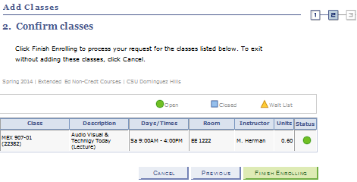
1. Login to my.csudh.edu and select “Student Center.” Click on “Enroll”
which is located under the “Academics” header.
2. Select Term
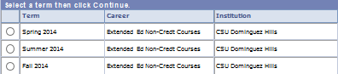

3. Click “Continue” (green bar)
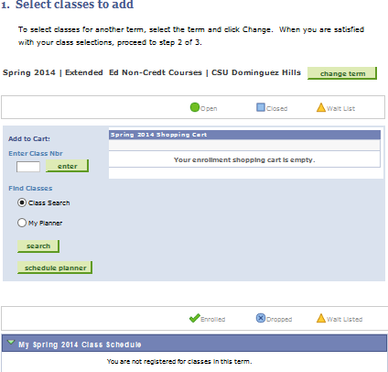
If your results show that you have errors, you must fix the error or add another class. If you cannot fix the error, you will not be added.

09. View your Results

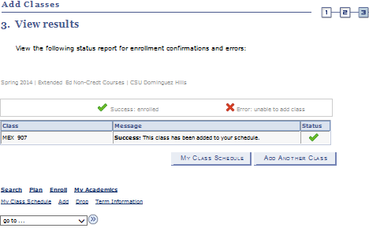

If you know your class number, you may enter it in this field.

Click this arrow and select account inquiry to calculate your tuition.
4. You may now enter your class selections.
5. Select the class you wish to add.
6. Once the class has been added to your “Shopping Cart” you may make your entries
permanent or continue to add additional classes.
10. Once you calculate your tuition use the same drop down to make your payment.
7. When you have finished adding classes, proceed to “Step 2 of 3”.
8. You must then press the “Finish Enrolling” Button:

