Injury & Illness Prevention Program
Job Safety Analysis Form
1000 E Victoria St.• Carson, CA 90747
Phone: 310-243-3000 • Office: 310-243-3171
www.csudh.edu/ehs

Picture of task/equipment: | Task: |  | Chain Saws
 | Name of Shop or Dept: |  | CSUDH Campus - Grounds
 | Job Title(s): |  | Grounds Maintenance
 | Analyzed by: |  | M. Williams
 | Date: |  | 10/1/2021
Required PPE:
Work Boots | Gloves | Hearing Protection | Safety Glasses | Hard Hat | Mask/Face Protection
☒ | ☒ | ☒ | ☒ | ☒ | ☒

Required/Recommended Trainings:
Slip, Trip, Fall Safety |  | Equipment Safety Precautions
TASK | HAZARDS |  |  | CONTROLS
Operating a Chain Saw  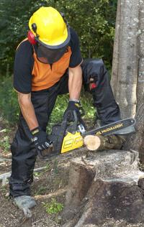 | Lacerations  Amputations  Struck By’s  Caught in between  Burns  Trip  Fall  Pinch |  |  | Don PPE, including work boots, gloves, hearing protection, Hard Hat, dust mask and face protection.  A Safety vest should also be worn when working during moving vehicles, such as roadways or other all-terrain vehicles.  Always keep both hands on the two handles while in operation. Firm hand placement will prevent kickback.  It is best to cut at higher speeds to reduce the chain locking up or pinching.  Never cut above shoulder height as these awkward positions can result in strains, kickback or falling debris.  Never perform cutting operations when people are nearby, make sure your work area is clear.  Never start the chainsaw while it is in contact with any material.  Do not start the chainsaw indoors as CO₂ vapors are harmful if inhaled. Only use in well ventilated areas.  When cutting a limb under tension, be aware of possible spring back once the wood fibers are cut.  Never cut with the tip or nose of the saw, this can result in kickback towards the body.  Shut off engine before setting down the chainsaw. It should only be running while in use.  Never touch the exhaust of the chain saw as it is extremely hot and will cause burns.

