Injury & Illness Prevention Program
Job Safety Analysis Form
1000 E Victoria St.• Carson, CA 90747
Phone: 310-243-3000 • Office: 310-243-3171
www.csudh.edu/ehs

Picture of task/equipment: | Task: | Pressure Washing
 | Name of Shop or Dept: | CSUDH Campus - Maintenance
 | Job Title(s):
 | Analyzed by: | M. Williams
 | Date: | 10/1/2021
Required PPE:
Slip-Resistant Boots | Gloves | Hearing Protection | Safety Glasses | Safety Vest | Mask/Face Protection
☒ | ☒ | ☐ | ☒ | ☒ | ☐

Required/Recommended Trainings:
TASK | HAZARDS |  | CONTROLS
Pressure washing with a Hotsy or Landa Washer  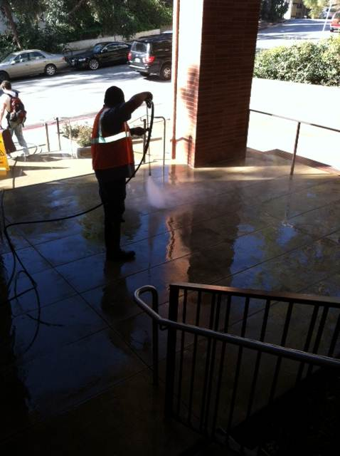 | Slips  Trips  Falls  Lacerations  Struck-by  Electrocution |  | Don booties and place wet floor signs in direct area before operating a pressure washer.  Use a safety vest when there is risk of vehicular traffic in the area.  Safety glasses shall be worn to prevent particles from flying up and coming in contact with eyes.  Be familiar with how to turn off machine and bleed pressure out before operating the equipment.  Make sure electrical connections are grounded using a 3-prong outlet.  Keep water spray away from electric wiring or electric shock may result.  Always hold the spray gun with both hands to prevent kick back.  Firmly grip spray gun before starting to prevent gun from whipping and causing bodily harm.  Never spray washer towards persons or vehicles as it can cause bodily harm.  Do not attempt to overreach or stand on an unstable footing while operating equipment.  Never leave equipment unattended.

