Injury & Illness Prevention Program
Job Safety Analysis Form
1000 E Victoria St.• Carson, CA 90747
Phone: 310-243-3000 • Office: 310-243-3171
www.csudh.edu/ehs

Picture of task/equipment: | Task: | Stihl Gas Powered Hedge Trimmer
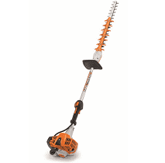 | Name of Shop or Dept: | CSUDH Campus - Grounds
 | Job Title(s):
 | Analyzed by: | Orson Faynor
 | Date: | 11/9/2021
Required PPE:
Work Boots | Gloves | Hearing Protection | Safety Glasses | Safety Vest | Mask/Face Protection
☒ | ☒ | ☐ | ☒ | ☐ | ☐

Required/Recommended Trainings:
IIPP Equipment Specific
TASK | HAZARDS |  | CONTROLS
Use  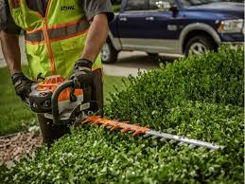 | Amputations  Lacerations  Falls |  | Do not operate machine when fatigued. If you are tired, take a break. Tiredness may result in loss of control.  To reduce the risk of injury from blade contact, never carry or transport power tool with the blades moving.  Before starting machine be sure the cutting tool is clear of you and all other obstructions and objects to prevent blade contact.  Always hold the unit firmly with both hands on the handles when you are working. Wrap your fingers and thumbs around the handles.  Always operate the machine so that the cutting blades are away from your body.  Do not overreach. Keep proper footing and balance at all times. Special care must be taken in slippery conditions and in difficult, overgrown terrain. Be extremely cautious when working on slopes and uneven ground.  To reduce the risk of injury from loss of control, never work on a ladder, in a tree or any other insecure support. Never hold the machine above shoulder height.  Always stop the engine and make sure the cutting blades are stopped before doing any maintenance or repair work or cleaning the tool.

