Injury & Illness Prevention Program
Job Safety Analysis Form
1000 E Victoria St.• Carson, CA 90747 Phone: 310-243-3000 • Office: 310-243-3171
www.csudh.edu/ehs
Picture of task/equipment: | Task: |  | Dumping waste with Vestil JMD-1000
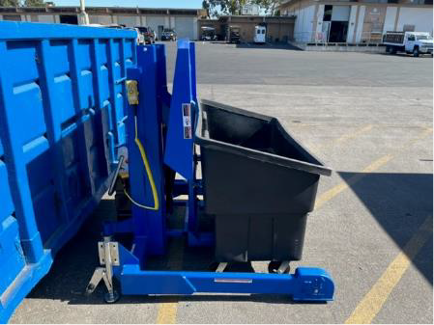 | Name of Shop  or Dept: |  | CSUDH Campus - Sustainability
 | Job Title(s): |  | Sustainability, Mover
 | Analyzed by: |  | M. Williams
 | Date: |  | 5/11/2022
Required PPE:
Work Boots Gloves Hearing Protection Safety Glasses Safety Vest Mask/Face Protection
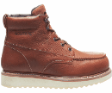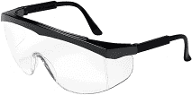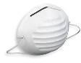
☒ ☐ ☐ ☒ ☐ ☐
Required/Recommended Trainings:
IIPP Equipment Specific
TASK | HAZARDS |  |  | CONTROLS
Dumping waste in the Vestil JMD-1000 tote dumper  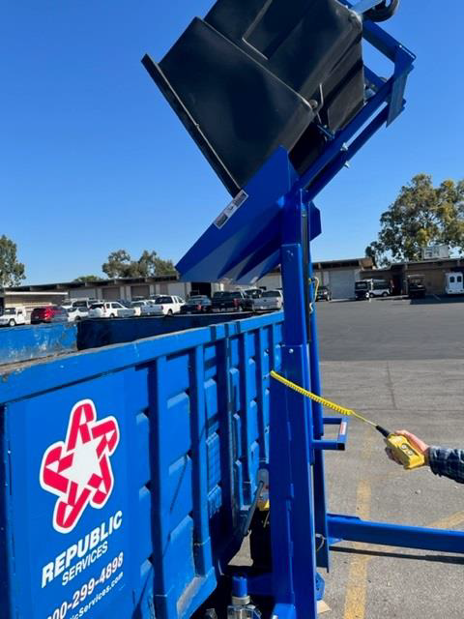 | Struck By’s Pinch Lacerations |  |  | D Inspect the tote for damage before each lift. Do not attempt to pick up the tote unless it is in good condition.  D Always have the floor lock engaged solidly with the floor surface when the dumper is in operation.  D Lock wheels before operation  D Verify that the tote is engaged and held securely by the dumper before proceeding to raise the tote.  D Always watch the dumper and the tote carefully when the dumper is in operation.  D Stand away from the side of the dumper when it is in operation. Stay clear of any potential pinch and shear points.  D Be alert to the possibility of splashing or flying material when dumping loads.  D Do not use the dumper if any damage or unusual noise is observed.  D When moving the dumper for charging, raise handlebar and push dumper to charging station  D Ensure wheels are locked when charging

