Injury & Illness Prevention Program
Job Safety Analysis Form
1000 E Victoria St.• Carson, CA 90747
Phone: 310-243-3000 • Office: 310-243-3171
www.csudh.edu/ehs

Picture of task/equipment: | Task: |  | Weed Trimmer
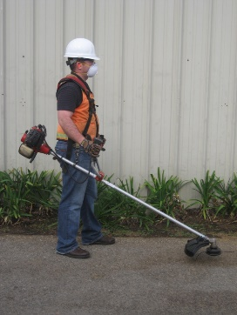 | Name of Shop or Dept: |  | CSUDH Campus - Grounds
 | Job Title(s): |  | Groundskeepers
 | Analyzed by: |  | M. Williams
 | Date: |  | 10/1/2021
Required PPE:
Work Boots | Gloves | Hearing Protection | Safety Glasses | Safety Vest | Mask/Face Protection
☒ | ☒ | ☒ | ☒ | ☒ | ☒

Required/Recommended Trainings:
Slip, Trip, Fall Safety |  | Equipment Safety Precautions
TASK | HAZARDS |  |  | CONTROLS
Operating a gas-powered  weed trimmer  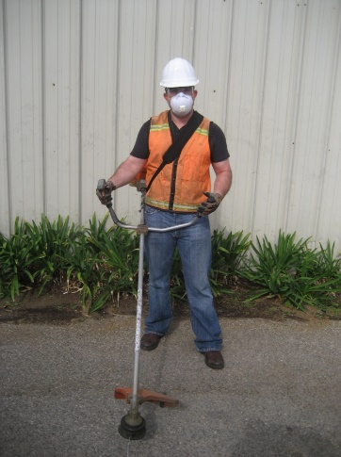 | Struck By’s  Lacerations  Slips  Trips  Falls  Vapor  Inhalation  Fire |  |  | Don PPE before starting equipment, including non-slip work boots, Gloves, Hearing Protection, Safety glasses, a mask and a safety vest (when working near public roadways).  Wear long pants, as flying debris can come in contact with lower limbs.  Make sure all guards are in place before operating equipment.  Inspect spark plug cap and lead to make sure they are not damaged, otherwise electric shock can occur.  Do not operate within 50ft of persons or traffic as injury or ricochet can occur.  Do not operate next to glass, such as windows.  Watch for uneven surfaces, holes and slopes; take extra care with footing to avoid STF’s.  Keep hands, arms and dry debris away from the muffler, it can result in burns or fires.  Never start the equipment indoors as exhaust can create a harmful breathing atmosphere.  Hold trimmer head just above ground and let the cord cut; never force the cutter into grass or weeds.  Do not try to make adjustments to the cutting cord while the machine is on.  Do not try to remove debris while the machine is in operation; make sure machine is off before clearing.

