CSUDH Guide: How to Create a New Study Protocol for CSUDH IRB Review

Welcome to the CSUDH IRB’s online computer program, Cayuse.

Two quirks to keep in mind:

- Clean your cache: You may need to clean the cache of your browser before logging in. Cayuse can be sluggish if the cache has not been emptied.

- CSUDH Authentication: Although you are ‘authenticated’ for 11 hours each time you log into a CSUDH portal, Cayuse may ask to authenticate every time you log in, regardless of when you last did so.

Please remember that only faculty and qualified administrators and staff can serve as PIs. Access to Cayuse is restricted to PIs. After entering all information about your protocol into Cayuse, the PI must certify that the information entered is accurate.

First: Log into Cayuse

- Go to https://csudh.app.cayuse.com/

- Log in (via SSO) with your CSUDH username and password.

- In the upper-right corner of the screen, just left of your name, you should see the word “Products.” Click on “Products” and select “Human Ethics” from the drop-down menu.

- In the upper part of the next screen, click on the blue button that says “+ New Study”.
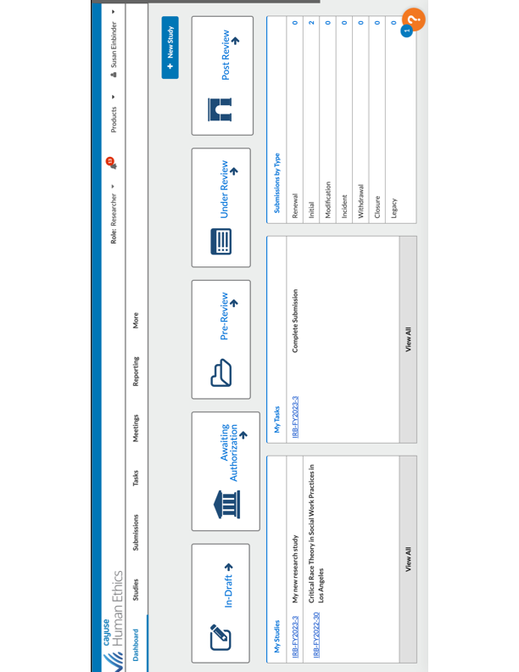

- On the next screen, enter the title of your study in the textbox, as shown by the red arrow below. When you are done, click the blue checkmark under the big text box.
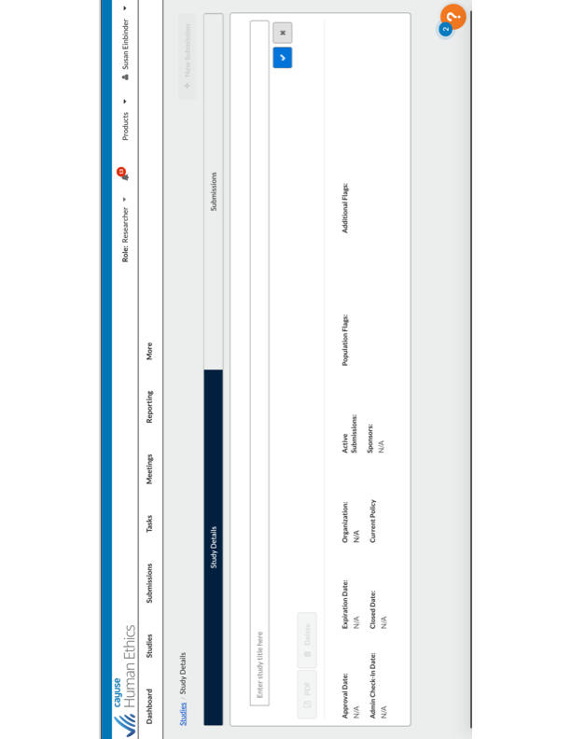

- Click on the blue button in the upper right of the screen that says “+ New Submission.”

- The next screen has your protocol’s title and number IRB number. Click on the Begin Initial Submission.
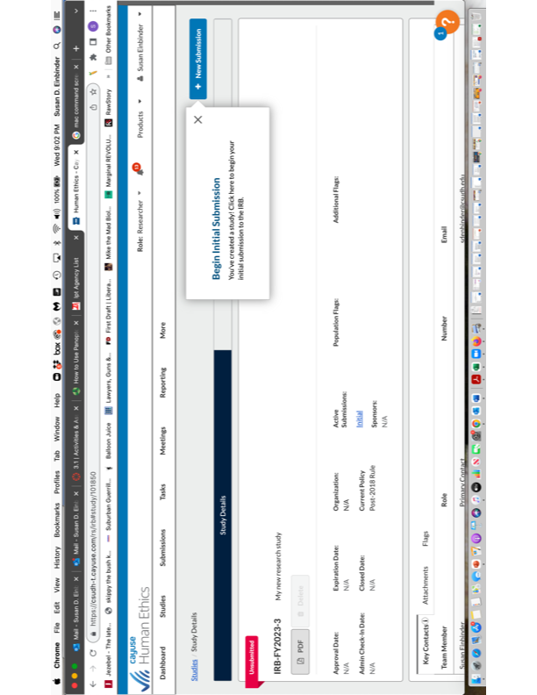

- The screen you now see has a red flag called “Unsubmitted.” Under that, your study title appears with its automatically assigned protocol number. Under that, there are three buttons: Click on grey button “Edit.”

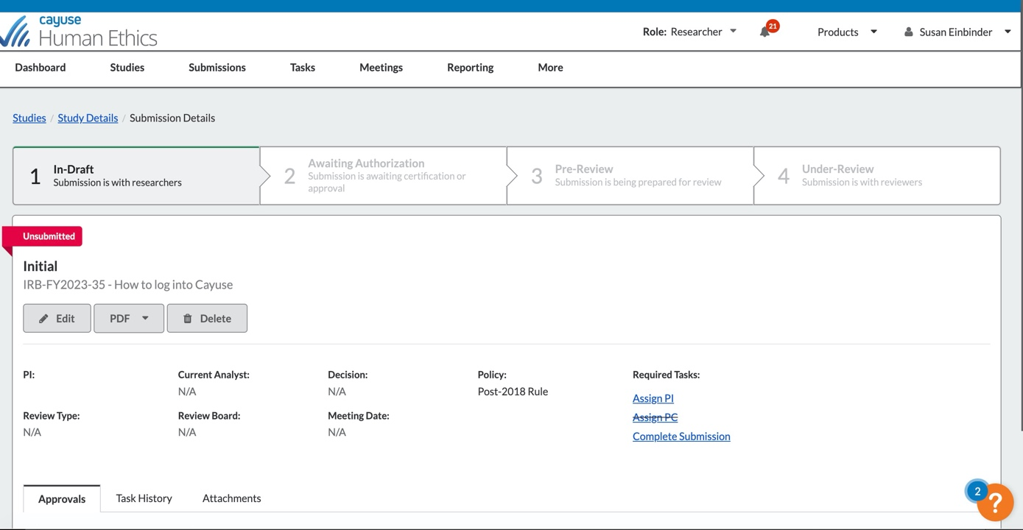

Now you are ready to enter the specifics of your protocol.

The Cayuse Home Page for Human Subjects: Starting a New Study

This is where you start to enter information about your proposed study.

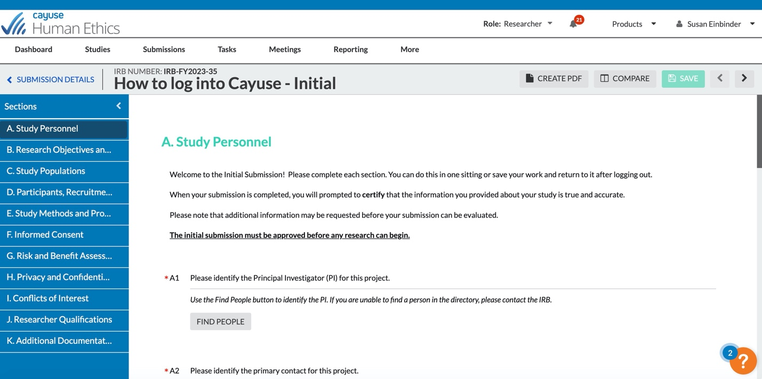

- The blue column on the left identifies different sections of the submission. You need to go through and answer all of the questions in each section. Once that is done, the section will have a white check-mark next to it: If a checkmark is missing, there is information missing from the section and the protocol cannot be submitted.

- To view what you will be asked to provide for each section, a template is available that shows, section by section, what you will see, and what information will be asked to provide, in the order of the sections. You can prepare the template in word, and then copy/paste the requested information into Cayuse, or just respond to the prompts without pre-preparation.

If students are assisting in designing the protocol, the template may be a useful tool for preparing the details that the PI will enter into Cayuse.

- Once everything is entered, scroll down a bit to see, in that blue column to the left, the button for Submission. Click on it. This will generate a new screen:

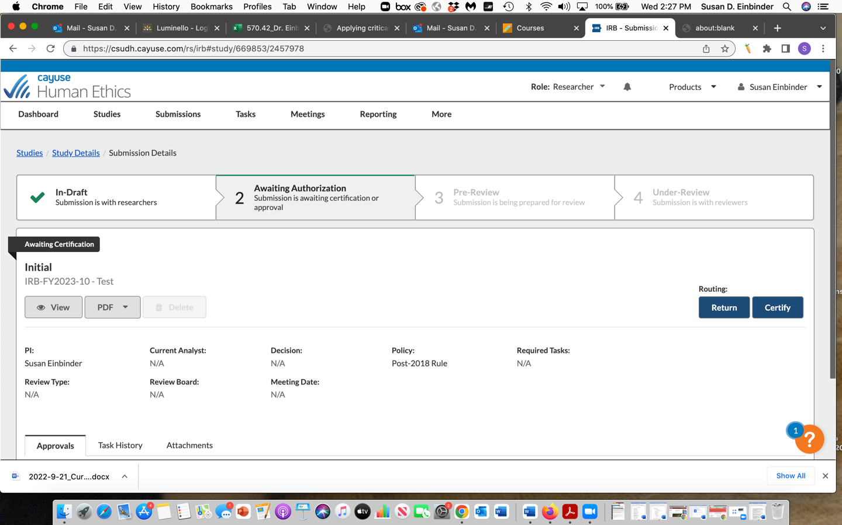

- On this screen, click on “Certify,” the last step in this process. This will prompt Cayuse to ask you to confirm the submission.

If you have questions, get stuck, need help negotiating the Cayuse program, or need clarification about what is being asked from you, please contact the CSUDH IRB at irb@csudh.edu.

Happy research!

